
Department of Computer Science
College of Computer and Cyber Sciences
SE431 – Software Maintenance and Evolution
Legacy Library Management System
Phase 1: Program Comprehension Analysis
Team Members
Student ID | Name
4311027 | Shahad Alhejali
4412442 | Ranyah Alharbi
4310689 | Sabrin Alqarni
4211073 | Aya Mohamd

Instructor: Saima Shaheen
Fall 2026 – 25 October 2026

1. Overview
All six original requirements are implemented, but the code mixes user interface, business logic and database access inside the same functions. We analysed the legacy code without changing it, using code reading, call tracing and schema inspection.
The legacy system is a single Python file (library.py) of about 100 lines that uses SQLite (library.db).

2. Requirements Confirmed from the Code
# | Requirement | Where it is implemented | Status
R1 | Active members can borrow | borrow(): if member[1] != "ACTIVE" | Confirmed
R2 | Maximum 3 books | borrow(): COUNT(*) ... returned=0, then >= 3 | Confirmed
R3 | Borrow only when available | borrow(): if book[0] == 0 | Confirmed
R4 | 14-day borrowing period | borrow(): timedelta(days=14) | Confirmed
R5 | Fine for late returns | return_book(): late = (today - due).days | Confirmed
R6 | Search for books | search_books(): LIKE on title or author | Confirmed

3. Business Rules
- A member must exist and have status ACTIVE to borrow.
- A book must exist and have available = 1 to be borrowed.
- A member may hold at most 3 loans with returned = 0.
- Due date = borrow date + 14 days.
- Fine = 1 unit per day late; no fine if returned on time. The currency is not defined.
- A return needs an active loan for the same member and book.
- Borrowing sets the book to unavailable; returning sets it back to available.
- Search is a partial, case-insensitive match on title or author.
Hidden rules and gaps found: the fine is printed but never stored; each book has only one copy; there is no function to add members or books; only ACTIVE is checked and other statuses are not defined.

4. Database Schema
Table | Columns | Notes
members | id TEXT PK, name, status | Status stored as plain text
books | id INTEGER PK, title, author, available | available is a 0/1 flag, one copy only
loans | id PK, member_id, book_id, borrow_date, due_date, returned | No foreign keys; no fine column

5. Current Architecture
The system is a single-file monolith with no layers. main() acts as the user interface and calls four functions, and each function talks to SQLite directly.
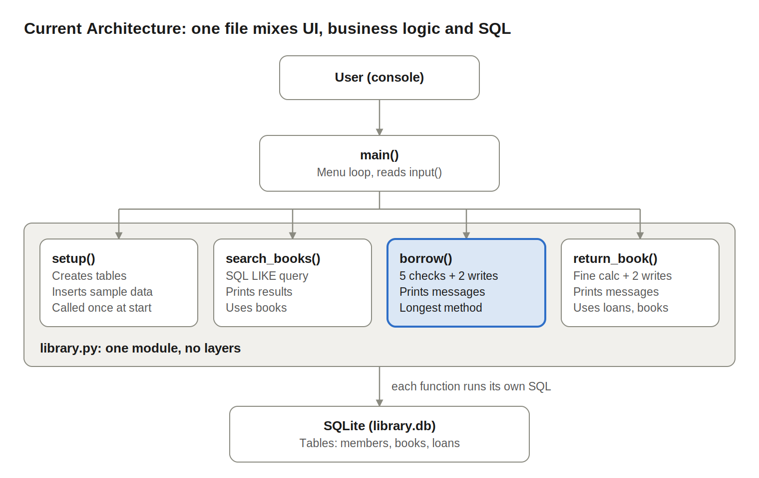
Figure 1. Current architecture of the legacy LMS
Every function receives the raw database connection and runs its own SQL, so the UI, logic and data layers cannot be separated or replaced. borrow() (highlighted) carries the most responsibilities.

6. Module Responsibility Table
Function | Responsibilities | Tables used | Lines (approx.)
setup() | Connect to DB, create tables, insert sample data | members, books, loans | 45
search_books() | Query books, print results | books | 12
borrow() | Validate member, book and limit; create loan; update book; print messages | members, books, loans | 50
return_book() | Find loan, compute fine, close loan, update book, print | loans, books | 35
main() | Menu loop, read input, call functions | none | 30

7. Dependency Analysis
- External dependencies: sqlite3 (all data functions) and datetime (borrow(), return_book()).
- Call dependencies: main() calls setup(), search_books(), borrow() and return_book(); no business function calls another.
- Data coupling: every function receives a raw db connection and writes its own SQL, so changing the database means changing every function (tight coupling).
- Most coupled function: borrow() reads three tables and writes to two.
- Data flow for borrowing: input in main() → check members → check books → count loans → insert into loans → update books → print due date.

8. Code Smells
# | Smell | Evidence in code | Effect
1 | Long Method | borrow() has five responsibilities | Hard to read and change
2 | Mixed responsibilities | print(), logic and SQL in one function | Logic cannot be reused without the console
3 | Magic numbers | 3, 14 and fine rate 1 hard-coded | Rule changes need a code search
4 | Primitive obsession | member[1], book[0], string "ACTIVE" | Fragile, unclear meaning
5 | Direct DB access | SQL inside every function | Blocks MR-02
6 | Duplicated code | Member/book input repeated in main() | Changes needed twice
7 | No error handling | int(input()) crashes on letters | Program stops
8 | Hard-coded data | Sample records inside setup() | Test data mixed with schema
9 | Boolean as integer | available, returned stored as 0/1 | Blocks MR-01 (copies)

9. Summary
The legacy LMS meets its functional requirements but is hard to maintain. Smells 5 and 9 directly shape the two maintenance requests (MR-02 and MR-01), and smells 1 to 4 are the targets of the refactoring phase.

